**Postcards**

**To: Children’s Director of SEND in Rotherham**

Thank you for listening to parent carers and young people and creating more provision for young people with SEND particularly Autism. It is lovely to see alternative provision that fully meets CYP needs by working together in co-production and working as equal partners. It is also lovely to see how these provisions are supporting independent living and life skills leading to employment.

**From: Kayleigh Harrison, Participation Co-ordinator**

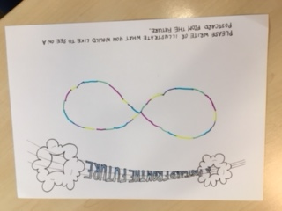

**------------------------------------------------------------------------------------------------------------------------------------**

**To: SYB ICS**

We are finally working together as a system to make life better for people with Autism. Stuart is now working towards an IT qualification; his family are much happier, and he is thriving and planning to travel. Carter is working with his TA and doing really well at school and getting ready to transition to mainstream high school.

**From: Kelly Glover, TCP Strategic Lead**

**------------------------------------------------------------------------------------------------------------------------------------**

**To: SYB ICS**

Hi mum, I am living independently and now work with Sheffield Parks and Gardens. I have made some good friends and we enjoy going out to clubs and climbing in the peak district. Loads of love.

**From: Phillipa Cormack, Parent Carer**

**------------------------------------------------------------------------------------------------------------------------------------**

**To: SYB ICS**

The single autism and neurodevelopmental assessment process has now been implemented and is applicable for all services from the DWP, social services, ECHP and employment.

South Yorkshire and Bassetlaw have created a single autism pathway which is cheaper to run becomes buck passing has been eliminated.

**From: Paul Cormack, Parent Carer**

**To: SYB ICS**

I came to the workshop 5 years ago and I am so heartened by how things have changed. I was shocked to hear the length of time that the same concerns had been discussed and felt so strongly that these same issues should not keep being discussed with no action. Now I am seeing inclusive education, sensory areas in all classrooms following the increased funding for schools. The number of young adults in employment contributing so positively to society is exactly what should be happening, and that Autism is no longer seen as ‘unusual.’

**Anne Robson, Inclusion Director**

**------------------------------------------------------------------------------------------------------------------------------------**

**To:**

Life is wonderful. All those with autism and learning disabilities and other unique needs are getting the necessary help very early on in life to enable them to have an impact across the generations – their own, their parents and their children.

**From:**

**------------------------------------------------------------------------------------------------------------------------------------**

**To: All**

We don’t hang on to our personal groups and egos. We are working collaboratively together for the good of the person with autism rather than for personal recognition or acknowledgement.

**From:**

**------------------------------------------------------------------------------------------------------------------------------------**

**To: Everyone**

EVERYONE needs to work together for the common good of people on the Autism spectrum.

**From: Jonathan Evans**

**------------------------------------------------------------------------------------------------------------------------------------**

**To: SYB ICS**

I have been on a number of Autism awareness training sessions and feel I am in the best place possible to offer tailored support to victims of hate crime who have Autism. I have also ensured that all front-line staff working for South Yorkshire Police are aware of the training opportunities available to them. Thank you for signposting me.

**From: Molly Fitzpatrick, Hate Crime Coordinator – Sheffield**

**------------------------------------------------------------------------------------------------------------------------------------**

**To: SYB ICS**

I dealt with an incident today involving an Autistic boy who had been assaulted. Due to the Sparkle Alert and the training I have received I was able to deal with the incident efficiently and effectively. I knew how to communicate with the victim and offer support where needed. Well done SYP.

**From: Lisa Fieldhouse, Police Constable**

**To:**

We have a partnership of Autistic people and professionals with a culture of active learning. We still don’t get everything right and want to be told when we don’t. We listen, learn then work together to get a tiny bit better every day.

**From: Richard Parrott, Commissioning Social Care**

**------------------------------------------------------------------------------------------------------------------------------------**

**To: SYB ICS**

I attended New York stadium for the Autism workshop. It was amazing to discuss all the necessary improvements that were required. What has impressed me the most though, is that you have all actually acted on what we shared with you about our journeys. It makes a refreshing change to see that the information we share has made a difference.

**From: Michaela Lunn, Parent and RPCF Volunteer**

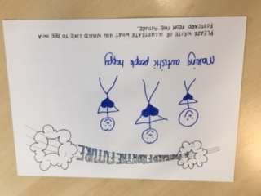

**------------------------------------------------------------------------------------------------------------------------------------**

**To: All – Government, NHS, Education**

To attain ‘Autism Friendly’ requires a step change in perceptions of autism, reduction of stigma and stereotyping, greater knowledge, understanding and compassion to ensure all environments, processes and systems have people/staff who accept, understand, want to learn from the Autistic and have systems designed by the autistic so everything becomes therapeutic.

**From: John**

**------------------------------------------------------------------------------------------------------------------------------------**

**To:**

Every person matters.

**From:**

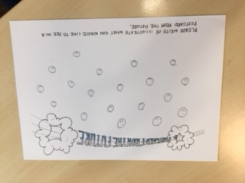

**------------------------------------------------------------------------------------------------------------------------------------**

**To: Prime Minister**

Today I visited a group with other mums and dads and I didn’t have to travel very far – it was just around the corner. They were really helpful and helped me to understand my child’s autism.

**From:**

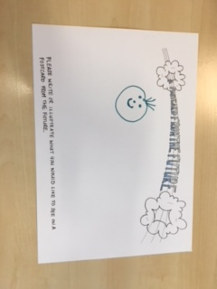

**------------------------------------------------------------------------------------------------------------------------------------**

**To: SYB ICS**

This week I went to the doctors about a concern of having Autism. He referred me for an appointment the next day for diagnosis. I was diagnosed in 3 days and had a social worker appointed as well as being given support services that are easily accessible.

**From: Andrew Bennett, Adult with Autism**

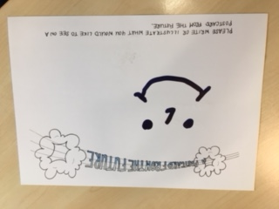

**------------------------------------------------------------------------------------------------------------------------------------**

**To: Secretary of State for Health, DWP, Education, Home Office**

Your job is to care for needs, not be a gatekeeper. Know your own department, ignore institutionalised senior officials but go mystery shopping. Know and follow your departments legal obligations. Be honest – how much do you really know?

Be proud of the improvements you can bring about.

Dear State, you put needs first, well well. And you found that meeting them promptly saved huge later expenses. Furthermore, you went home each night with a glow rather than a feeling of shame. You even managed to get education to be person-centred (as per their mission statement) rather than blinkered, cheap skates and punitive. Love and Kisses JK.

**From: John Kirkman**

**------------------------------------------------------------------------------------------------------------------------------------**

**To: SYB ICS**

Hello Gilly,

It’s you from the year 2022. It’s a better world now. There is more support for people who are going through diagnosis. There are more opportunities for support for people to enter employment if that’s what they want to do, and the reasonable adjustments are there for people to do that job.

**From: David Gill, Learning Disability and Autism Adviser**

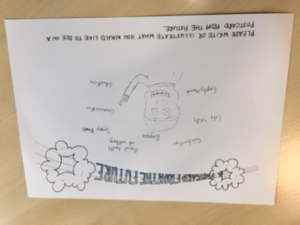

**To: SYB ICS**

32 Billion – finally we’ve spent it right! What a difference 3 years have made. Well done.

**From: Andrew Higgins, Partnership Adviser**

**------------------------------------------------------------------------------------------------------------------------------------**

**To: Everyone**

Whoever you are, whatever you do the world is your oyster. I’m well hope you are too! I’ve got friends, I’m living independently, finished school, got a great job with a supportive team – the office is great it meets my needs. We have lots of conversations and I’m really well. You don’t need to worry; the future is great – the world is your oyster.

**From: Local Authority and Health Colleagues**

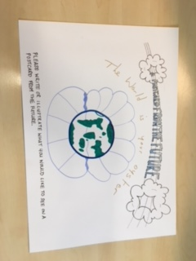

**------------------------------------------------------------------------------------------------------------------------------------**

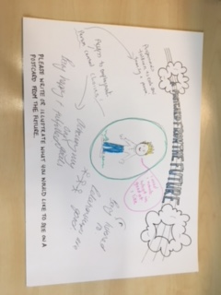

**------------------------------------------------------------------------------------------------------------------------------------**

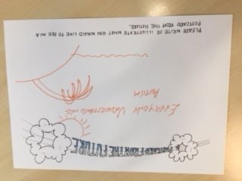

**From: Nick**

**------------------------------------------------------------------------------------------------------------------------------------**

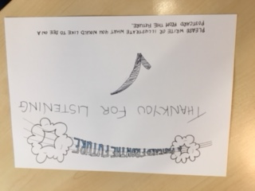

**From: DWP Partnership Team**

**------------------------------------------------------------------------------------------------------------------------------------**

**To:**

How nice. Society has changed its attitude to those on the autistic spectrum. Schools lookout for signs of ASC and have appropriately skilled professional and support staff to ensure that children’s needs are understood and catered for. Post diagnostic support for those diagnosed with ASC is readily available within the workplace where those with an ASC are integrated and welcomed. Parents whose time previously was spent worrying and supporting their autistic children are relaxing sound in the knowledge that their children are appropriately house and employed with support to enable them to engage in ‘normal’ life activities.

**From: Robert Carter**